Assessment Validation MEETING SUMMARY  12:30 – 15:00 Monday 30/06/2014 | 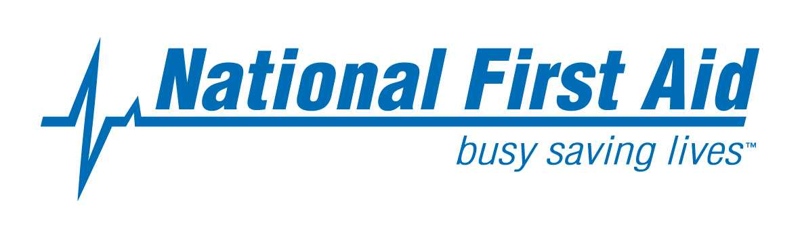

Meeting Venue
NFA Head Office, 296 Bay Road, Cheltenham, Victoria 3192

Attendees

Assessment Validation Members

Name Company
Robert Voss Staying Alive
Ann Eyears 1st Choice First Aid
Wayne Shrimpton WorkSecure Safety & Training
Laurie Blick Bellarine First Aid
Alicia Lands All First Aid Training
Sandy Symmons F.A.I.S
Carmel Allan Arbortrim Training & Consultancy
Vicky Pentney Carey Baptist Grammar School
Jennifer Kirk Hillcrest Christian College
Ann Coram NFA Sessional Trainer
Dave Potter NFA Sessional Trainer

NFA Staff Members

Beatrice Barnett Quality & Compliance Consultant
Nikki Eden Office Manager
Gavin Chan Compliance Manager

NFA Assessment Validation MEETING REPORT SUMMARY

- Beatrice Barnett who is the NFA Quality and Compliance Consultant welcomed all industries advisory committee members in Kym’s absence.
Kym is away on leave until mid August.

- Beatrice provided the industry with an overview of the significant and continuous changes that occurred since the last validating meeting. NFA has committed to provide co-providers with news updates to ensure that they remain current

  - Extension of the transition date of the HLTFA units of competency to 31st October 2014.
  - That a review panel has been convened to review industry comments regarding the HLTAID units – extract below from CHISC media centre.

First Aid
The Minister for Industry received comments and feedback about the first aid units from a number of RTOs. The decision to review the first aid units (HLTAID units) was taken as a result of these comments and feedback.
A new Subject Matter Expert Group (SMEG) has been convened to review the content of these units. Members of this group represent the following organisations:
- Australian Council for Private Education and Training
- Australian Defence Force
- Australian Emergency Care Providers
- Australian Resuscitation Council
- Council of Ambulance Authorities
- Department of Industry
- Health Services Union
- Red Cross
- Royal Life Saving
- St Johns Ambulance
- Surf Life Saving
- TAFE Directors Australia
The SMEG has now met on 2 occasions to determine what changes/clarification are required, once the SMEG has signed off on the proposed changes, these will be available for public consultation, on our website, in the next few weeks. This consultation will be promoted in our newsletter.
Due to this review ASQA, VRQA and TAC (WA) have announced an extension of the transition period for superseded First Aid units of competency to be October 30 2014:
This applies to RTOs that have not already transistioned to the following new units:

HLT07 superseded unit | HLT Replacement Units
HLTCPR211A Perform CPR | HLTAID001
HLTFA211A Provide basic emergency life support | HLTAID002
HLTFA311A Apply first aid | HLTAID003
HLTFA302C Provide first aid in remote situation | HLTAID005
HLTFA412A Apply advanced first aid | HLTAID006
HLTFA404C Apply advanced resuscitation techniques | HLTAID007

Please note that the newly endorsed HLTAID008 unit transition timeframe is not affected by any of the proposed changes and will transition on 30 June 2014.
The transition date for each authority is:
Authority | Transition date | Notes | Further information
ASQA | 30th October 2014 | This does not represent any change to ASQA’s General Direction: Transition and Teach out which must be complied with at all times | ASQA INFOLINE:  1300 701 801 enquiries@asqa.gov.au
VRQA | 31 October 2014 |  | VRQA  03 9637 2806

3. Clarification was given on two training package requirements;
a) Do we need to do 4 minutes of continuous CPR?
To assist below is extract from training package HLTAID001 –Performance evidence states:
- performed at least four minutes of uninterrupted CPR on both an adult and an infant resuscitation manikin placed on the floor, demonstrating the following techniques on each:
  - checking for response and normal breathing
  - recognising abnormal breathing
  - opening and clearing the airway
  - using correct hand location, compression depth rate in line with the ARC recommended ratio of compressions and ventilations
  - acting in the event of regurgitation or vomiting
  - following single rescuer procedure, including the demonstration of a rotation of operators with minimal interruptions to compressions
This implies that it is 4 minutes from the D for Danger to C for CPR and the handing over to another rescuer in that time frame.
It does NOT mean 4 minutes of continuous/non interrupted CPR by participants.

b) Must a participant demonstrate CPR on the floor? Is this discriminatory?

With reference to the above extract from the training unit of competency it clearly states on the floor.
We cannot deem participants competent otherwise. It was agreed by industry members for integrity and quality outcomes that participants with temporary disability ie knee injury should be asked to complete the course at a later date.
It needs to be clearly stated to all participants that a condition of accreditation that they MUST be able to demonstrate CPR on the floor prior to enrolment/commencement of training. If a participant cannot demonstrate on the floor then a Certificate of Attendance can only be issued. This requirement has been included on all NFA relevant course outlines on the NFA web.

4. Beatrice then led a consultation session with the industries Committee Members. Members were provided with assessment resources for all four units (HLTAID001, HLTAID002, HLTAID003 and HLTAID004) to review and update prior to this session.
Copies and the accompanying TAS was also issued during this session.

The following items were discussed/approved:
- Addition of non applicable to the checklists – this was corrected
- Rewording of some of the questions on the Theory Assessment – this was corrected
- Answer sheet for trainers to be provided – this was available but not distributed.
- TAS was reviewed/verified for each unit and no changes made. TAS met industry requirements.
- The Assessments for all units were reviewed and approved for content and instruction – minor adjustments were made as outlined above.
- It was agreed that the principles of assessment and rules of evidence were met by all units.
- Regarding Handling and Maintenance of documentation – the industry group approved the policies and procedures and implementation of such to ensure record management.
- The methodology for the training resources in a companion format was approved by the industry group.

Please note – all relevant corrections were made from this validation meeting.
The corrected documents and all other assessment and training documents were included in the companions for each unit of competency and are now available on the NFA website for all approved co-providers.

5. The meeting concluded at 3:30pm.

