Industries Advisory Committee  MEETING SUMMARY  10:00 – 12:00 Monday 30/06/2014 | 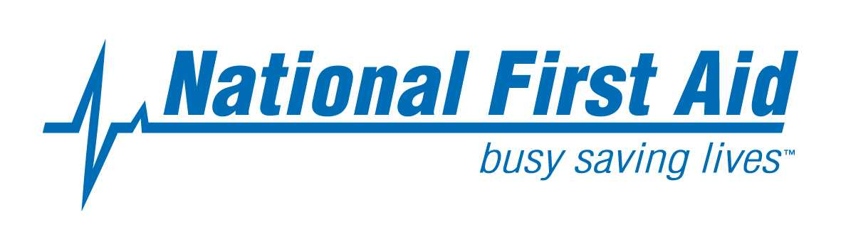

Meeting Venue
NFA Head Office, 296 Bay Road, Cheltenham, Victoria 3192

Attendees

Industries Advisory Committee Members

Name Company
Robert Voss Staying Alive
Ann Eyears 1st Choice First Aid
Wayne Shrimpton WorkSecure Safety & Training
Laurie Blick Bellarine First Aid
Alicia Lands All First Aid Training
Sandy Symmons F.A.I.S
Carmel Allan Arbortrim Training & Consultancy
Vicky Pentney Carey Baptist Grammar School
Jennifer Kirk Hillcrest Christian College
Louise Niklaus Destiny Training Outcomes
Ann Coram NFA Sessional Trainer
Dave Potter NFA Sessional Trainer
Cheryl Napthine NFA Sessional Trainer

NFA Staff Members

Beatrice Barnett Quality & Compliance Consultant
Nikki Eden Office Manager
Gavin Chan Compliance Manager

NFA Industries Advisory Committee MEETING REPORT SUMMARY

- Beatrice Barnett who is the NFA Quality and Compliance Consultant welcomed all industries advisory committee members in Kym’s absence. Kym is away on leave until mid August.

- Marketing and advertising practices of Australia’s RTO by ASQA
The Strategic_Reviews_2013_Marketing_and_Advertising_Report was distributed and specific reference made to Chapter 4-Non-RTOs marketing and advertising nationally recognised training. A link has been provided for your reference.

In general, this review identified a number of concerns about the nature of non-RTO marketing and advertising services, some of which are in common with the concerns identified in relation to RTO practices including:
- fee information and practices;
- lack of transparency for consumers in the brokerage arrangements and lack of currency of published
- information;
- conduct that could be seen as potentially misleading and deceptive; and
- non-RTOs falsely claiming to be RTOs or purporting to be able to offer RTO services.
- This issue of non-RTO service provision has the potential to undermine the objective of the standards to ensure nationally consistent, high-quality training and assessment services for the clients of Australia’s VET system as non-RTOs are not obliged to comply with the national standards for RTOs.

It is was discussed that all co providers comply to the requirements of the NFA Agreement specifically
- Part 30 Advertising and Marketing
All Co-Providers must clearly identify NFA as the approved RTO, specifically the NFA RTO number (3981) on their Advertising and Marketing materials directly relating to accredited first aid training. All advertising materials and marketing strategies from NFA approved Co-providers must fully comply to AQTF conditions, standards and VRQA guidelines.

Key outcomes:
- Co-providers must reference NFA as the approved RTO on all advertising and marketing material –suggested “your company has an agreement with National First Aid (NFA), the registered training organization (RTO 3981). NFA will issue the statements of attainment for the accredited training. For general training inquiries these should be referred to your company.
- Co-Providers to update their websites to reflect new AID units of competency
- NFA will continuously review co provider web sites and request marketing material to ensure compliance to NFA agreement and that no participant is mislead or disadvantaged.
- NFA can review any material submitted by Co- provider prior to release or print. This will avoid unnecessary re prints or retractions at a later date.

- Expiry of Program 22024VIC Course in Emergency Management of Asthma
- The attached document was discussed outlining that this accredited course will expire on 31 December 2014. Please note this course is a requirement for Schools in Victoria along with the Anaphylaxis course. Childcare industry has the new HLTAID004 which includes these courses. A separate email to all co-providers was sent via the NFA web news to clarify any misunderstandings and misinformation in the industry.
- At this point in time we understand that it is being updated and will be re submitted to VRQA for registration. We expect to be advised by September 2014 regarding the RTO requirements for addition to scope and for transition.
- The other accredited courses below will expire Dec 2015:
  - 22099VIC Course in First Aid Management of Anaphylaxis
  - 22100VIC - Course in Basic Oxygen Administration
  - 22101VIC - Course in Automated External Defibrillation

Key outcomes:
- Co- Providers will be advised of the imminent changes and how these will impact on their delivery of this course
- Co-providers understand the requirement of this course for schools and how that differs from childcare
- Also mentioned that the co-provider resources on the web will be updated and a companion developed to assist in training and assessment documentation – similar to the new AID units. (to be discussed in more detail below)

- Proposed unit of competency for business development

- It was agreed that the scope of registration for NFA is first aid specific and limited.
- It was also agreed that the need exists to broaden the scope and incorporate aligned units of competency for business growth for both NFA and co –providers.
- Some of the units of competency suggested were:

  - HLTHSE204D Follow safe manual handling practices
  - PUAWER004B Respond to workplace emergencies
  - UETTDRRF06B Perform rescue from a live LV panel

- Based on the survey results NFA will advise priority and timing of the above proposed additions to scope

- Please note that the following will be added to scope progressively, this was agreed at the NOV 2013 Industry Meeting
  - HLTAID005 Provide first aid in remote situations
  - HLTAID006 Provide advanced first aid
  - HLTAID007 Provide advanced resuscitation
  - HLTAID008 Manage first aid services and resources

- New Units – access and submission

- The AID units 001 -004 are now on NFA scope of registration, effective 7 June 2014.
- Beatrice demonstrated the new methodology for access to the training material. A companion has been developed for each unit of competency that has all the required revised documents for training and assessment.
- A similar companion will be developed for Asthma and Anaphylaxis accredited courses on the web.
- It was agreed that this companion was a better approach and will ensure that submitted documentation to NFA for issuance of statements of Attainment is both current and compliant.
- The resources have been uploaded on the NFA website for access for all accredited co-providers.
- Regarding transition- it was discussed and agreed that NFA will allow co-providers to offer the HLTFA units of competency until 31st October however would strongly recommend that co-providers offer the new HLTAID as soon as possible as long as no participant is disadvantaged.
- The HLTFA resources are no longer available on the NFA web. Should you require these resources you will need to contact NFA administration.

- Fraudulent statement of attainment industry practices and NFA response

- To ensure that statements of attainment issued by NFA are not copied and that no participant is misled or advantaged, NFA introduced a non reproducible watermark that ensures that fraudulent statements of attainment are readily identified. This was also a requirement for compliance.
- The implementation was to be effective immediately and agreed by this industry meeting.

- Survey Monkey
- Beatrice demonstrated access to the web based participant and client feedback process.
Client: https://www.surveymonkey.com/s/NFA-Client-Pre-Training-Survey
Participant: https://www.surveymonkey.com/s/NFA-Participant-Survey

- This process does not negate the hardcopy feedback form requested at the end of each training courses, it is intended for participants who would like to submit their feedback electronically and possibly after the training. Co-providers are to advise participants of their options.
- It was discussed that participants do not have to complete feedback form however – co providers need to make the feedback available.
- The hardcopy feedback form has been updated and available to all co providers from the website and has synergy with the Survey Monkey questions.

8. A survey has been taken as the end of the Industries Advisory Committee Meeting. The following results have been analysed:

Part 1 of the survey
 |  | Overall Percentage %
 |  | Strongly Disagree | Disagree | Neutral | Agree | Strongly Agree
Questions | Information provided at NFA Industries Consultation is relevant to you and your company | 0 | 0 | 10 | 45 | 45
Questions | You are likely to use the information from NFA Industries Consultation in the future. | 0 | 0 | 0 | 45 | 55
Questions | Resources provided are relevant, useful and appropriate. | 0 | 0 | 0 | 64 | 36
Questions | Presentations and discussions from NFA Industries Consultation were interesting. | 0 | 0 | 18 | 46 | 36
Questions | NFA Industries Consultation provides opportunities to network with stakeholders. | 0 | 0 | 18 | 36 | 46
Questions | Overall, the NFA Industries Consultation is worthwhile to attend. | 0 | 0 | 0 | 55 | 45
Questions | You are likely to attend the NFA Industries Consultation in Nov. 2014. | 0 | 0 | 0 | 55 | 45

Part 2 of the survey

Regarding the information related to the 22024VIC Course in the Emergency Management of Asthma in the Workplace accredited course.
- 10% agree to remove from NFA scope of registration
- 82% agree to transition to the new course when it is made available
- 18% not answer or not applicable to their organisation.

Regarding the impact related to marketing and advertising practices, most of the answered question indicated that they would like to work with NFA to ensure compliance in their marketing and advertising strategy.

Regarding business development to add units to the scope of registration, the approved percentages are:
45 | LV Panel & CPR (HLTAID001 & UETTDRRF06B) skills set
82 | Respond to Workplace Emergencies PUAWER004B (Fire evacuation)
64 | Course in Safe Handling of Sharps and Infectious Waste (10340NAT)
64 | Follow Safe Manual Handling Practices HLTHSE204D

9. The meeting concluded at 12:30pm.

